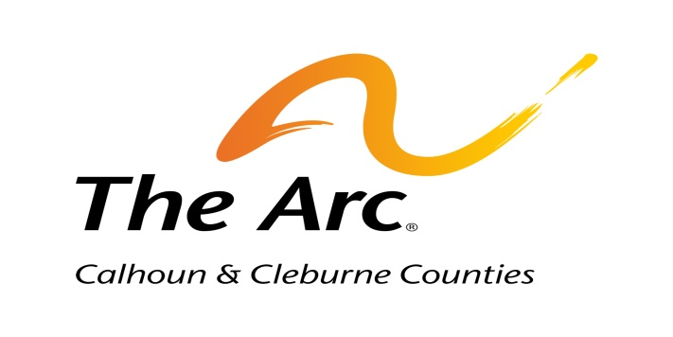

Invites you to join us at our

Annual Meeting, Awards Banquet and Fashion Show

Thursday, November 17, 2022

Oxford Civic Center
401 McCullars Lane, Oxford, Al

Beginning at 5:30 p.m. in the gymnasium

(All current members of The Arc are asked to join us for a brief General Membership Meeting in the auditorium at 5:00 p.m. to approve the slate of officers/board of directors)

Please confirm your reservation at 256-236-2857 or Info@calhouncleburnearc.org
By Thursday, November 10.

