The Arc of Calhoun and Cleburne Counties
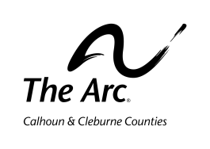
Membership Application

Applicant Information
Name:

Title: Mr. Mrs. Ms. | Cell: | Other phone:
Address:

City, State ZIP:

Email:

SPOUSE INFORMATION (IF fAMILY mEMBERSHIP)
Name:

Address (if different from above)

City, State, ZIP

Email:

RELATIONSHIP TO The Arc (please circle)
Self-Advocate Parent or relative of self-advocate

Professional in the Field of ID/DD Interested Citizen

DEMOGRAPHIC INFORMATION (please circle)
Age Range: under 50 over 50 Choose not to provide

Ethnicity: Hispanic or Latino White African American Native Hawaiian or Other Pacific Islander Asian

American Indian 2 or more races Choose not to provide
Member Signature:

For The Arc of Calhoun and Cleburne County use
Type of Membership: Family Individual Student Complimentary Honorary
Amount paid:
Membership begins:
Expiration date:

